UNITED STATES
SECURITIES AND EXCHANGE COMMISSION
Washington, D.C. 20549

FORM 8-K

CURRENT REPORT

PURSUANT TO SECTION 13 OR 15(d) OF THE
SECURITIES EXCHANGE ACT OF 1934

Date of report (Date of earliest event reported): August 19, 2026

Binah Capital Group, Inc.
(Exact name of registrant as specified in its charter)

Delaware |  | 001-41991 |  | 88-3276689
(State or Other Jurisdiction  of Incorporation) |  | (Commission File Number) |  | (I.R.S. Employer  Identification Number)

80 State Street, Albany, NY 12207
(Address of principal executive offices, including zip code)

Registrant’s telephone number, including area code: (212) 404-7002

(Former name or former address, if changed since last report)

Check the appropriate box below if the Form 8-K filing is intended to simultaneously satisfy the filing obligation of the registrant under any of the following provisions:

☐ | Written communications pursuant to Rule 425 under the Securities Act (17 CFR 230.425)

☐ | Soliciting material pursuant to Rule 14a-12 under the Exchange Act (17 CFR 240.14a-12)

☐ | Pre-commencement communications pursuant to Rule 14d-2(b) under the Exchange Act (17 CFR 240.14d-2(b))

☐ | Pre-commencement communications pursuant to Rule 13e-4(c) under the Exchange Act (17 CFR 240.13e-4(c))

Securities registered pursuant to Section 12(b) of the Act:

Title of Each Class |  | Trading Symbols |  | Name of Each Exchange on Which  Registered
Common Stock, par value $0.0001 per share |  | BCG |  | The Nasdaq Stock Market LLC
Warrants, each exercisable for one share of Common Stock at an exercise price of $11.50 per share |  | BCGWW |  | The Nasdaq Stock Market LLC

Indicate by check mark whether the registrant is an emerging growth company as defined in Rule 405 of the Securities Act of 1933 (§230.405 of this chapter) or Rule 12b-2 of the Securities Exchange Act of 1934 (§240.12b-2 of this chapter).

Emerging growth company ☐

If an emerging growth company, indicate by check mark if the registrant has elected not to use the extended transition period for complying with any new or revised financial accounting standards provided pursuant to Section 13(a) of the Exchange Act. ☐

Item 7.01 Regulation FD Disclosure.

On August 19, 2026, Binah Capital Group, Inc. (“Binah”) is furnishing as Exhibit 99.1 to this Current Report on Form 8-K an investor presentation dated August 2026, which will be used in discussions with investors and analysts beginning on August 19, 2026 at the Sidoti Virtual Micro Cap Conference, which may also be used, in whole or in part, and subject to modification, at subsequent meetings with investors and analysts.

The information in this current report on Form 8-K, including the investor deck attached as Exhibit 99.1 hereto, is being furnished, but shall not be deemed to be “filed” for purposes of Section 18 of the Securities Exchange Act of 1934, as amended, or otherwise subject to the liabilities of that section or Sections 11 and 12(a)(2) of the Securities Act of 1933, as amended. The information contained herein and in the accompanying exhibit shall not be incorporated by reference into any filing with the U.S. Securities and Exchange Commission made by Binah, whether made before or after the date hereof, regardless of any general incorporation language in such filing.

Item 9.01. Financial Statements and Exhibits.

(d) Exhibits.

Exhibit No. |  | Description
99.1 |  | Investor Deck, dated August 2026.
104 |  | Cover Page Interactive Data File (embedded within the Inline XBRL document).

SIGNATURES

Pursuant to the requirements of the Securities Exchange Act of 1934, the registrant has duly caused this report to be signed on its behalf by the undersigned hereunto duly authorized.

Dated: August 19, 2026

 | BINAH CAPITAL GROUP, INC.
 | By: | /s/ Craig Gould
 | Name: | Craig Gould
 | Title: | Chief Executive Officer and Director

Exhibit 99.1


NASDAQ:BCG Across all business models. AUGUST 2026 Empowering Independent Advisors

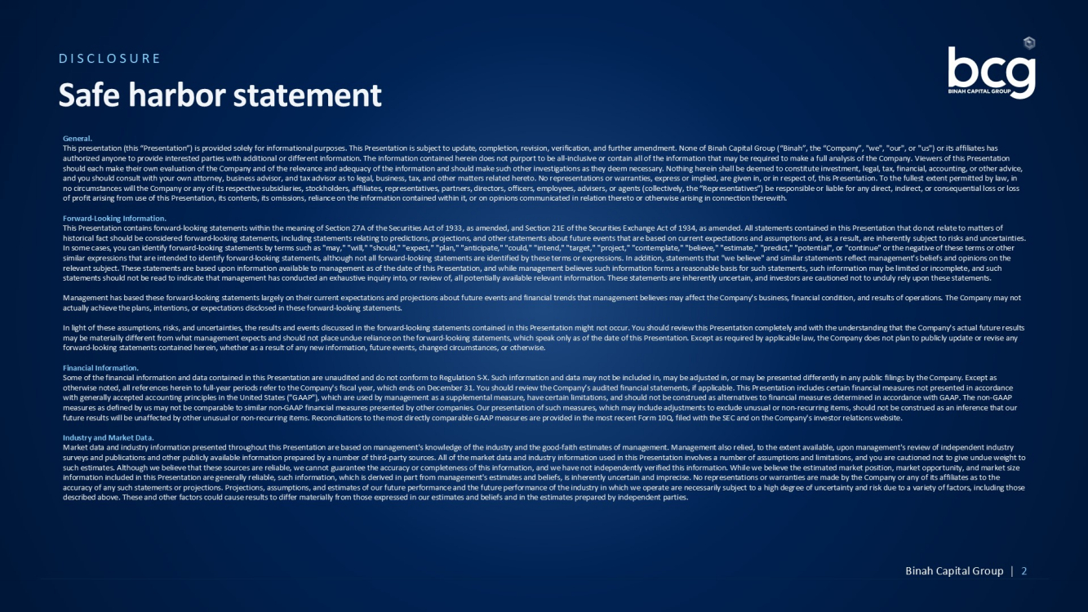
General. This presentation (this “Presentation”) is provided solely for informational purposes. This Presentation is subject to update , c ompletion, revision, verification, and further amendment. None of Binah Capital Group (“Binah”, the “Company”, "we", "our", o r " us") or its affiliates has authorized anyone to provide interested parties with additional or different information. The information contained herein do es not purport to be all - inclusive or contain all of the information that may be required to make a full analysis of the Company. V iewers of this Presentation should each make their own evaluation of the Company and of the relevance and adequacy of the information and should make suc h o ther investigations as they deem necessary. Nothing herein shall be deemed to constitute investment, legal, tax, financial, a cco unting, or other advice, and you should consult with your own attorney, business advisor, and tax advisor as to legal, business, tax, and other matter s r elated hereto. No representations or warranties, express or implied, are given in, or in respect of, this Presentation. To th e f ullest extent permitted by law, in no circumstances will the Company or any of its respective subsidiaries, stockholders, affiliates, representatives, partners, di rectors, officers, employees, advisers, or agents (collectively, the “Representatives”) be responsible or liable for any dire ct, indirect, or consequential loss or loss of profit arising from use of this Presentation, its contents, its omissions, reliance on the information contained within it , o r on opinions communicated in relation thereto or otherwise arising in connection therewith. Forward - Looking Information. This Presentation contains forward - looking statements within the meaning of Section 27A of the Securities Act of 1933, as amende d, and Section 21E of the Securities Exchange Act of 1934, as amended. All statements contained in this Presentation that do not relate to matters of historical fact should be considered forward - looking statements, including statements relating to predictions, projections, and other statements about future events that are based on current expectations and assumptions and, as a result, are inherently sub ject to risks and uncertainties. In some cases, you can identify forward - looking statements by terms such as "may," "will," "should," "expect," "plan," "anticipa te," "could," "intend," "target," "project," "contemplate," "believe," "estimate," "predict," "potential", or "continue" or t he negative of these terms or other similar expressions that are intended to identify forward - looking statements, although not all forward - looking statements are id entified by these terms or expressions. In addition, statements that "we believe" and similar statements reflect management's be liefs and opinions on the relevant subject. These statements are based upon information available to management as of the date of this Presentation, an d w hile management believes such information forms a reasonable basis for such statements, such information may be limited or in com plete, and such statements should not be read to indicate that management has conducted an exhaustive inquiry into, or review of, all potenti all y available relevant information. These statements are inherently uncertain, and investors are cautioned not to unduly rely u pon these statements. Management has based these forward - looking statements largely on their current expectations and projections about future events and financial trends that management believes may affect the Company's business, financial condition, and results of operatio ns. The Company may not actually achieve the plans, intentions, or expectations disclosed in these forward - looking statements. In light of these assumptions, risks, and uncertainties, the results and events discussed in the forward - looking statements cont ained in this Presentation might not occur. You should review this Presentation completely and with the understanding that th e C ompany's actual future results may be materially different from what management expects and should not place undue reliance on the forward - looking statements, which speak only as of the date of this Presentation. Except as required by applicable law, the Company does not plan to publ icl y update or revise any forward - looking statements contained herein, whether as a result of any new information, future events, changed circumstances, o r otherwise. Financial Information. Some of the financial information and data contained in this Presentation are unaudited and do not conform to Regulation S - X. Su ch information and data may not be included in, may be adjusted in, or may be presented differently in any public filings by the Company. Except as otherwise noted, all references herein to full - year periods refer to the Company's fiscal year, which ends on December 31. You s hould review the Company’s audited financial statements, if applicable. This Presentation includes certain financial measures no t presented in accordance with generally accepted accounting principles in the United States ("GAAP"), which are used by management as a supplemental m eas ure, have certain limitations, and should not be construed as alternatives to financial measures determined in accordance wit h G AAP. The non - GAAP measures as defined by us may not be comparable to similar non - GAAP financial measures presented by other companies. Our present ation of such measures, which may include adjustments to exclude unusual or non - recurring items, should not be construed as an i nference that our future results will be unaffected by other unusual or non - recurring items. Reconciliations to the most directly comparable GAAP measures are provided in the most recent Form 10Q, filed with the SEC and on the Company's investor relations website. Industry and Market Data. Market data and industry information presented throughout this Presentation are based on management's knowledge of the indust ry and the good - faith estimates of management. Management also relied, to the extent available, upon management's review of indepen dent industry surveys and publications and other publicly available information prepared by a number of third - party sources. All of the market data and industry information used in this Presentation involves a number of assumptions and limitations, and you are caution ed not to give undue weight to such estimates. Although we believe that these sources are reliable, we cannot guarantee the accuracy or completeness of this in formation, and we have not independently verified this information. While we believe the estimated market position, market op por tunity, and market size information included in this Presentation are generally reliable, such information, which is derived in part from management' s e stimates and beliefs, is inherently uncertain and imprecise. No representations or warranties are made by the Company or any of its affiliates as to the accuracy of any such statements or projections. Projections, assumptions, and estimates of our future performance and the fut ure performance of the industry in which we operate are necessarily subject to a high degree of uncertainty and risk due to a var ie ty of factors, including those described above. These and other factors could cause results to differ materially from those expressed in our estimates and b eli efs and in the estimates prepared by independent parties. DISCLOSURE Safe harbor statement Binah Capital Group | 2

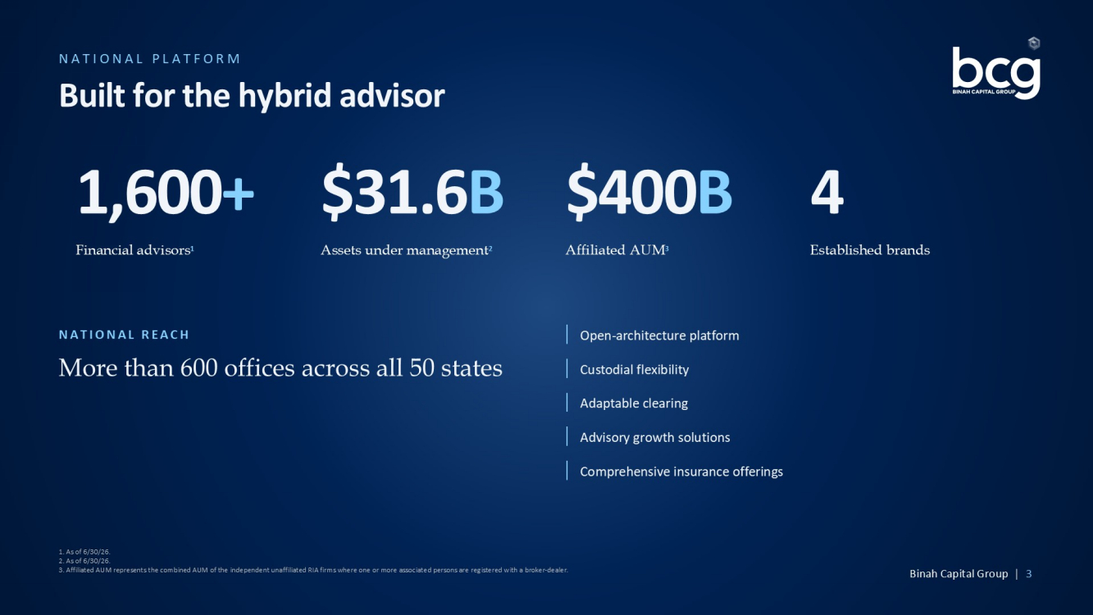
NATIONAL PLATFORM Built for the hybrid advisor 1,600 + Financial advisors 1 $31.6 B Assets under management 2 $400 B Affiliated AUM 3 4 Established brands NATIONAL REACH More than 600 offices across all 50 states Open - architecture platform Custodial flexibility Adaptable clearing Advisory growth solutions Comprehensive insurance offerings 1. As of 6/30/26. 2. As of 6/30/26. 3. Affiliated AUM represents the combined AUM of the independent unaffiliated RIA firms where one or more associated persons are registered with a broker - dealer. Binah Capital Group | 3

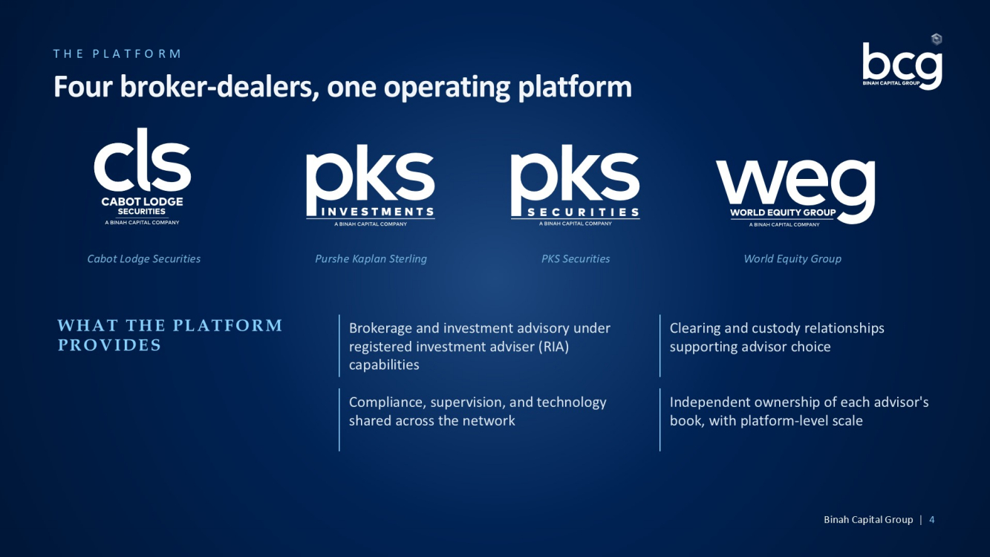
THE PLATFORM Four broker - dealers, one operating platform Cabot Lodge Securities Purshe Kaplan Sterling PKS Securities World Equity Group WHAT THE PLATFORM PROVIDES Brokerage and investment advisory under registered investment adviser (RIA) capabilities Clearing and custody relationships supporting advisor choice Compliance, supervision, and technology shared across the network Independent ownership of each advisor's book, with platform - level scale Binah Capital Group | 4

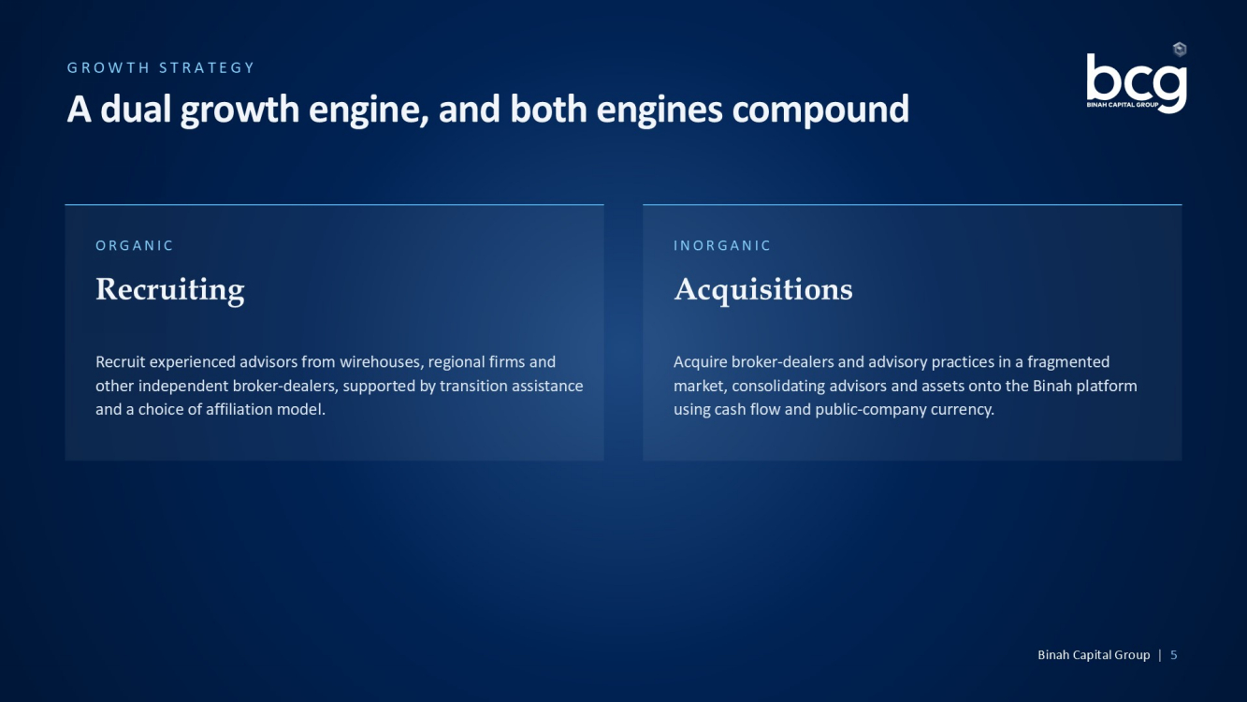
GROWTH STRATEGY A dual growth engine, and both engines compound ORGANIC Recruiting Recruit experienced advisors from wirehouses, regional firms and other independent broker - dealers, supported by transition assistance and a choice of affiliation model. INORGANIC Acquisitions Acquire broker - dealers and advisory practices in a fragmented market, consolidating advisors and assets onto the Binah platform using cash flow and public - company currency. Binah Capital Group | 5

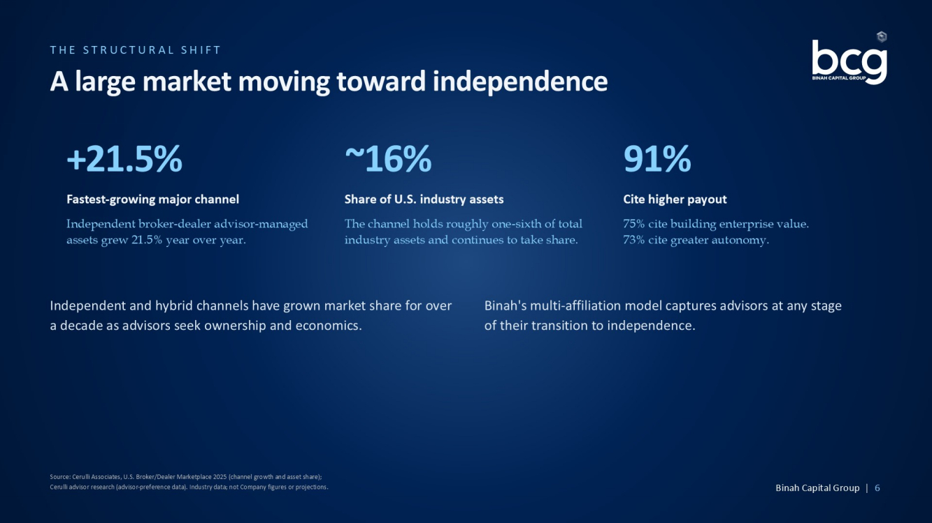
THE STRUCTURAL SHIFT A large market moving toward independence +21.5% Fastest - growing major channel Independent broker - dealer advisor - managed assets grew 21.5% year over year. ~16% Share of U.S. industry assets The channel holds roughly one - sixth of total industry assets and continues to take share. 91% Cite higher payout 75% cite building enterprise value. 73% cite greater autonomy. Independent and hybrid channels have grown market share for over a decade as advisors seek ownership and economics. Binah's multi - affiliation model captures advisors at any stage of their transition to independence. Source: Cerulli Associates, U.S. Broker/Dealer Marketplace 2025 (channel growth and asset share); Cerulli advisor research (advisor - preference data). Industry data; not Company figures or projections. Binah Capital Group | 6

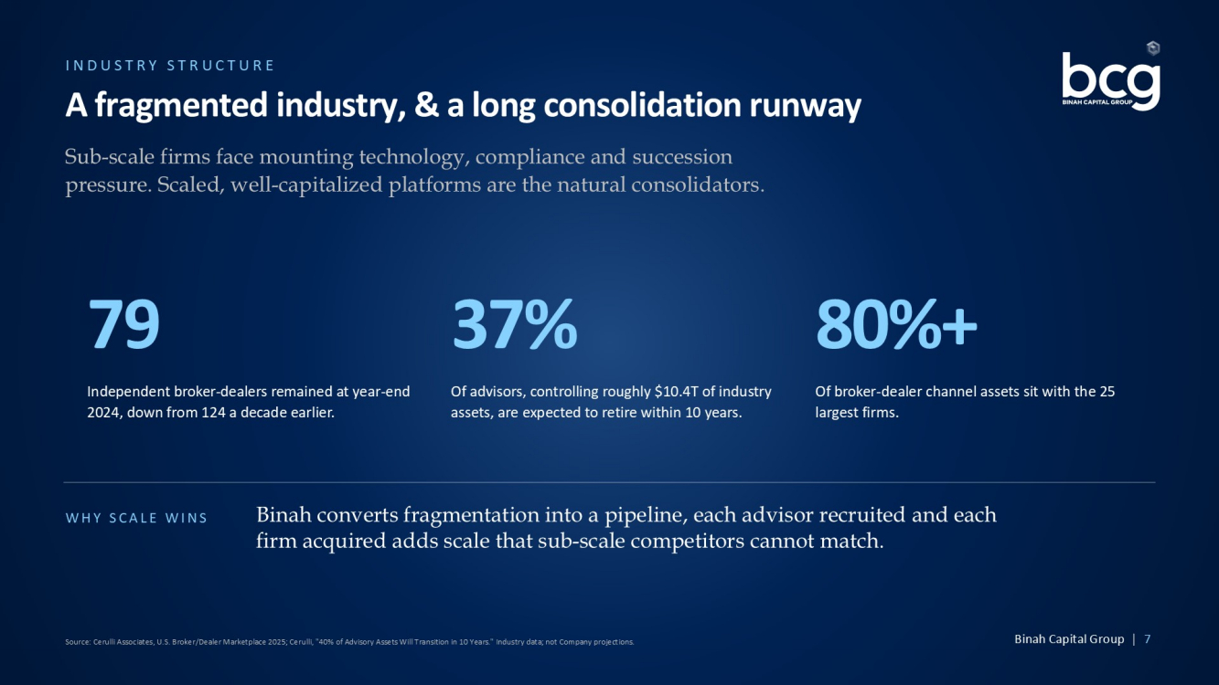
INDUSTRY STRUCTURE A fragmented industry, & a long consolidation runway Sub - scale firms face mounting technology, compliance and succession pressure. Scaled, well - capitalized platforms are the natural consolidators. 79 Independent broker - dealers remained at year - end 2024, down from 124 a decade earlier. 37% Of advisors, controlling roughly $10.4T of industry assets, are expected to retire within 10 years. 80%+ Of broker - dealer channel assets sit with the 25 largest firms. WHY SCALE WINS Binah converts fragmentation into a pipeline, each advisor recruited and each firm acquired adds scale that sub - scale competitors cannot match. Source: Cerulli Associates, U.S. Broker/Dealer Marketplace 2025; Cerulli, "40% of Advisory Assets Will Transition in 10 Years ." Industry data; not Company projections. Binah Capital Group | 7

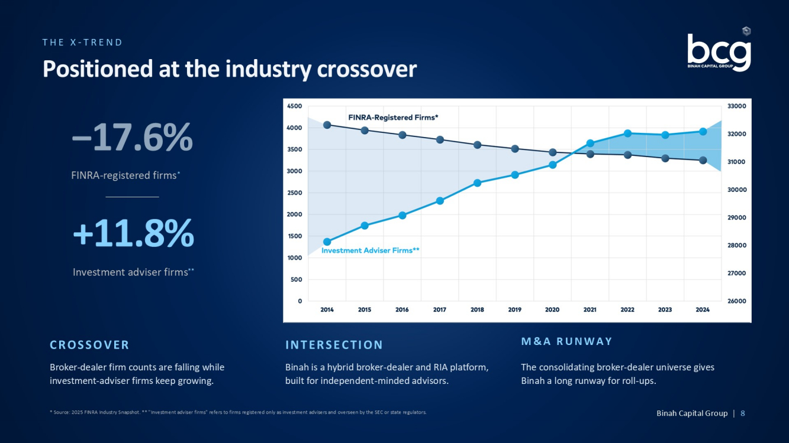
THE X - TREND Positioned at the industry crossover −17.6% FINRA - registered firms * +11.8% Investment adviser firms ** CROSSOVER Broker - dealer firm counts are falling while investment - adviser firms keep growing. INTERSECTION Binah is a hybrid broker - dealer and RIA platform, built for independent - minded advisors. M&A RUNWAY The consolidating broker - dealer universe gives Binah a long runway for roll - ups. * Source: 2025 FINRA Industry Snapshot. ** "Investment adviser firms" refers to firms registered only as investment advisers and overseen by the SEC or state regulators. Binah Capital Group | 8

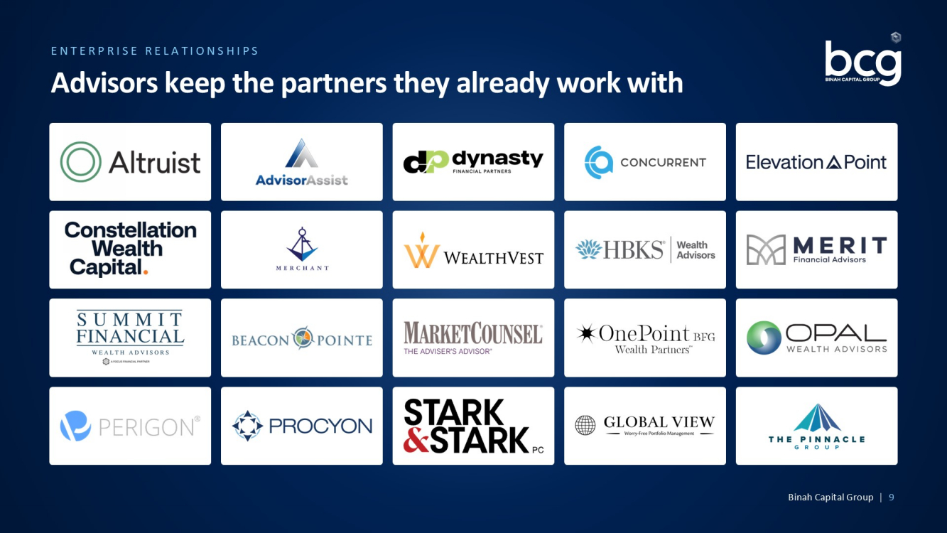
ENTERPRISE RELATIONSHIPS Advisors keep the partners they already work with Binah Capital Group | 9

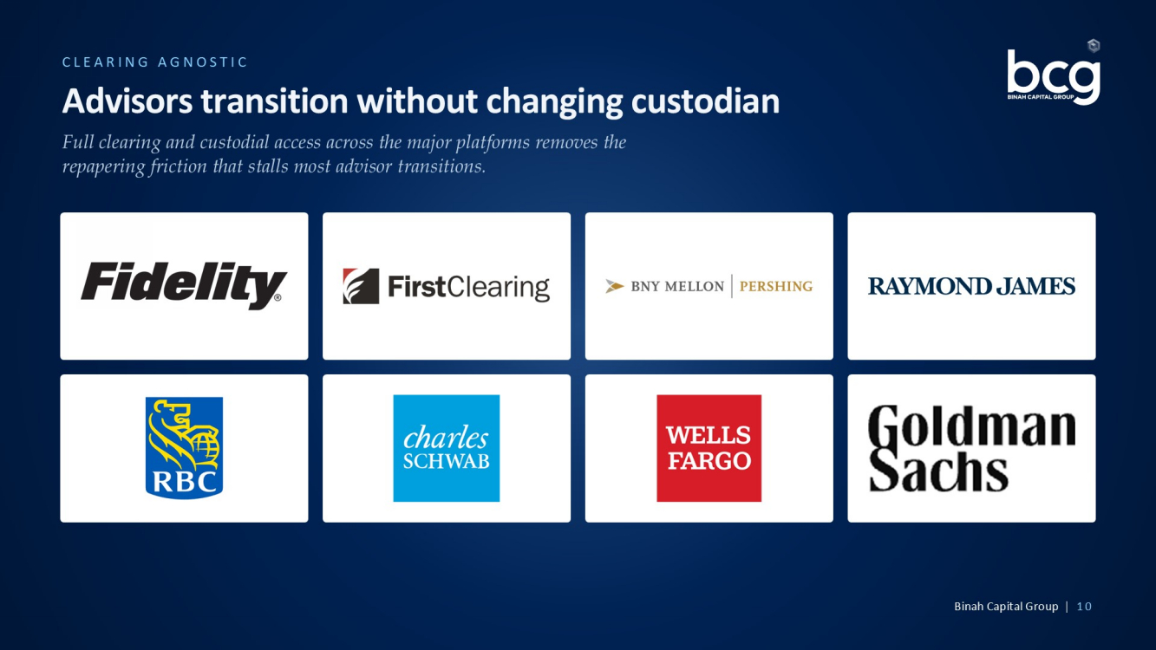
CLEARING AGNOSTIC Advisors transition without changing custodian Full clearing and custodial access across the major platforms removes the repapering friction that stalls most advisor transitions. Binah Capital Group | 10

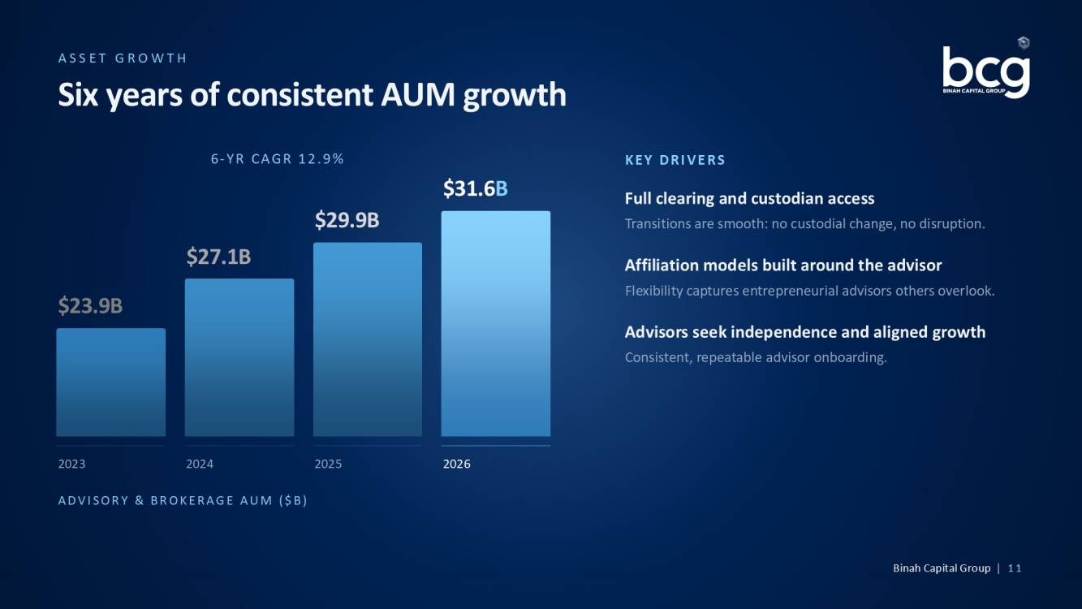
ASSET GROWTH Six years of consistent AUM growth ADVISORY & BROKERAGE AUM ($B) 6 - YR CAGR 12.9% $23.9B 2023 $27.1B 2024 $29.9B 2025 $31.6 B 2026 KEY DRIVERS Full clearing and custodian access Transitions are smooth: no custodial change, no disruption. Affiliation models built around the advisor Flexibility captures entrepreneurial advisors others overlook. Advisors seek independence and aligned growth Consistent, repeatable advisor onboarding. Binah Capital Group | 11

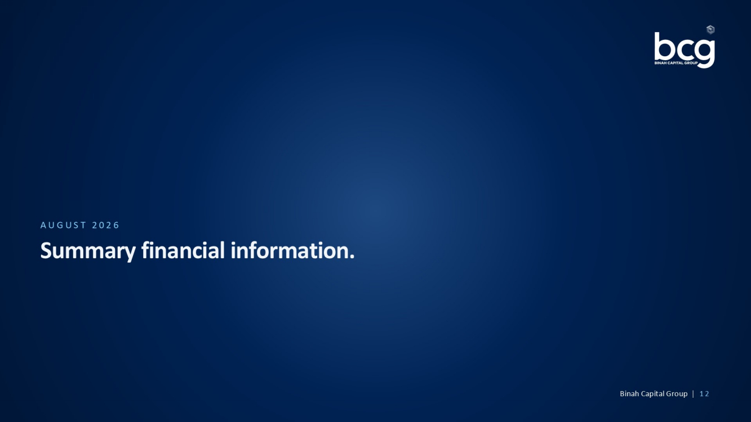
AUGUST 2026 Summary financial information. Binah Capital Group | 12

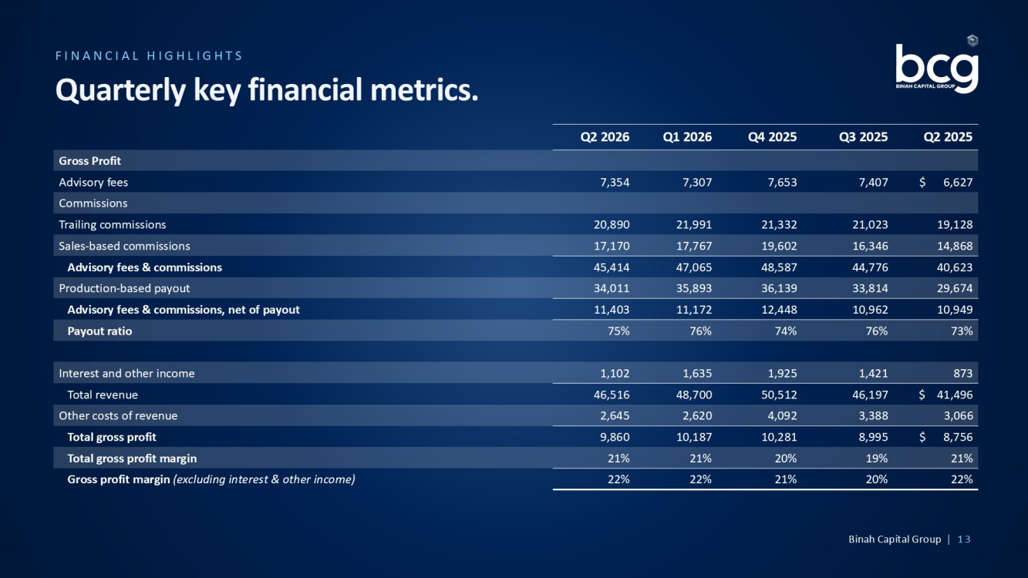
FINANCIAL HIGHLIGHTS Quarterly key financial metrics. Q2 2025 Q3 2025 Q4 2025 Q1 2026 Q2 2026 Gross Profit $ 6,627 7,407 7,653 7,307 7,354 Advisory fees Commissions 19,128 21,023 21,332 21,991 20,890 Trailing commissions 14,868 16,346 19,602 17,767 17,170 Sales - based commissions 40,623 44,776 48,587 47,065 45,414 Advisory fees & commissions 29,674 33,814 36,139 35,893 34,011 Production - based payout 10,949 10,962 12,448 11,172 11,403 Advisory fees & commissions, net of payout 73% 76% 74% 76% 75% Payout ratio 873 1,421 1,925 1,635 1,102 Interest and other income $ 41,496 46,197 50,512 48,700 46,516 Total revenue 3,066 3,388 4,092 2,620 2,645 Other costs of revenue $ 8,756 8,995 10,281 10,187 9,860 Total gross profit 21% 19% 20% 21% 21% Total gross profit margin 22% 20% 21% 22% 22% Gross profit margin (excluding interest & other income) Binah Capital Group | 13

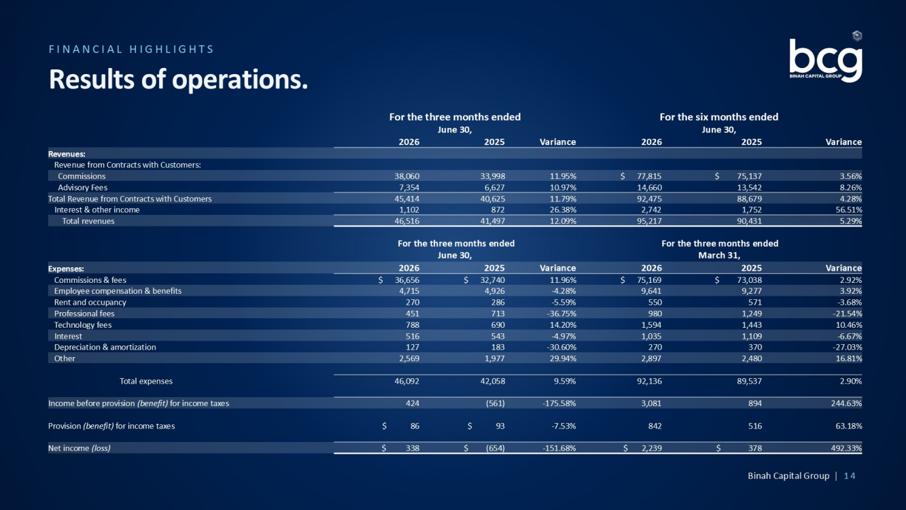
FINANCIAL HIGHLIGHTS Results of operations. For the six months ended June 30, For the three months ended June 30, Variance 2025 2026 Variance 2025 2026 Revenues: Revenue from Contracts with Customers: 3.56% $ 75,137 $ 77,815 11.95% 33,998 38,060 Commissions 8.26% 13,542 14,660 10.97% 6,627 7,354 Advisory Fees 4.28% 88,679 92,475 11.79% 40,625 45,414 Total Revenue from Contracts with Customers 56.51% 1,752 2,742 26.38% 872 1,102 Interest & other income 5.29% 90,431 95,217 12.09% 41,497 46,516 Total revenues For the three months ended March 31, For the three months ended June 30, Variance 2025 2026 Variance 2025 2026 Expenses: 2.92% $ 73,038 $ 75,169 11.96% $ 32,740 $ 36,656 Commissions & fees 3.92% 9,277 9,641 - 4.28% 4,926 4,715 Employee compensation & benefits - 3.68% 571 550 - 5.59% 286 270 Rent and occupancy - 21.54% 1,249 980 - 36.75% 713 451 Professional fees 10.46% 1,443 1,594 14.20% 690 788 Technology fees - 6.67% 1,109 1,035 - 4.97% 543 516 Interest - 27.03% 370 270 - 30.60% 183 127 Depreciation & amortization 16.81% 2,480 2,897 29.94% 1,977 2,569 Other 2.90% 89,537 92,136 9.59% 42,058 46,092 Total expenses 244.63% 894 3,081 - 175.58% (561) 424 Income before provision (benefit) for income taxes 63.18% 516 842 - 7.53% $ 93 $ 86 Provision (benefit) for income taxes 492.33% $ 378 $ 2,239 - 151.68% $ (654) $ 338 Net income (loss) Binah Capital Group | 14

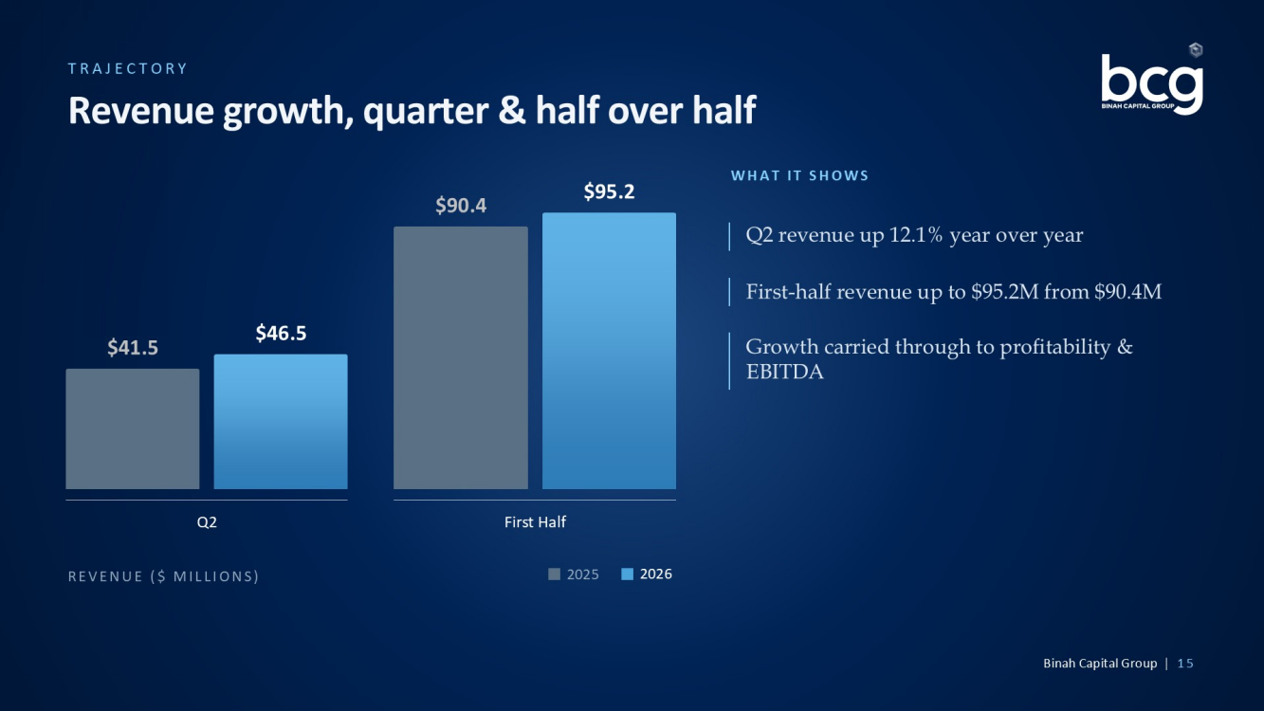
TRAJECTORY Revenue growth, quarter & half over half REVENUE ($ MILLIONS) 2025 2026 $41.5 $46.5 Q2 $90.4 $95.2 First Half WHAT IT SHOWS Q2 revenue up 12.1% year over year First - half revenue up to $95.2M from $90.4M Growth carried through to profitability & EBITDA Binah Capital Group | 15

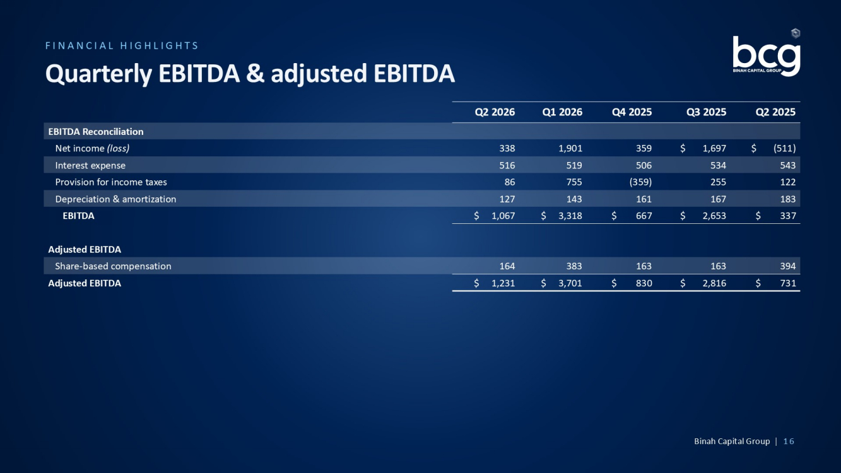
FINANCIAL HIGHLIGHTS Quarterly EBITDA & adjusted EBITDA Q2 2025 Q3 2025 Q4 2025 Q1 2026 Q2 2026 EBITDA Reconciliation $ (511) $ 1,697 359 1,901 338 Net income (loss) 543 534 506 519 516 Interest expense 122 255 (359) 755 86 Provision for income taxes 183 167 161 143 127 Depreciation & amortization $ 337 $ 2,653 $ 667 $ 3,318 $ 1,067 EBITDA Adjusted EBITDA 394 163 163 383 164 Share - based compensation $ 731 $ 2,816 $ 830 $ 3,701 $ 1,231 Adjusted EBITDA Binah Capital Group | 16

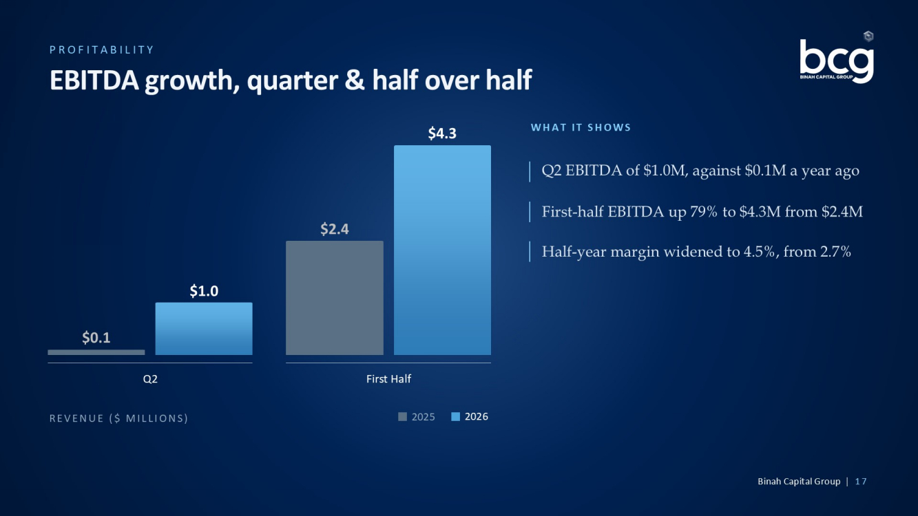
PROFITABILITY EBITDA growth, quarter & half over half REVENUE ($ MILLIONS) 2025 2026 $0.1 $1.0 Q2 $2.4 $4.3 First Half WHAT IT SHOWS Q2 EBITDA of $1.0M, against $0.1M a year ago First - half EBITDA up 79% to $4.3M from $2.4M Half - year margin widened to 4.5%, from 2.7% Binah Capital Group | 17

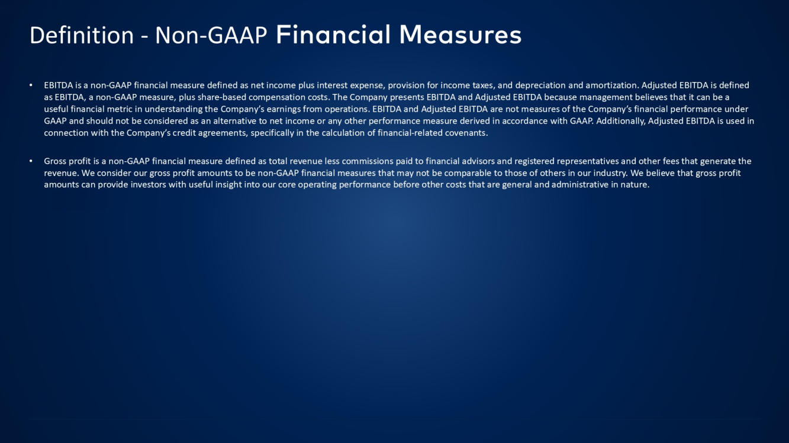
Definition - Non - GAAP Financial Measures • EBITDA is a non - GAAP financial measure defined as net income plus interest expense, provision for income taxes, and depreciation and amortization. Adjusted EBITDA is defined as EBITDA, a non - GAAP measure, plus share - based compensation costs. The Company presents EBITDA and Adjusted EBITDA because mana gement believes that it can be a useful financial metric in understanding the Company’s earnings from operations. EBITDA and Adjusted EBITDA are not measures of the Company’s financial performance under GAAP and should not be considered as an alternative to net income or any other performance measure derived in accordance with GA AP. Additionally, Adjusted EBITDA is used in connection with the Company’s credit agreements, specifically in the calculation of financial - related covenants. • Gross profit is a non - GAAP financial measure defined as total revenue less commissions paid to financial advisors and registered representatives and other fees that generate the revenue. We consider our gross profit amounts to be non - GAAP financial measures that may not be comparable to those of others in our industry. We believe that gross profit amounts can provide investors with useful insight into our core operating performance before other costs that are general and ad ministrative in nature.

